Andrew Dykman – Software Development Lifecycles – Lab 7

Phase | Classes and Components
Phase I | Survey, m_Questions, m_NumQuestions, m_SurveyName, m_Creator, m_Date, AddQuestion, GetQuestion, CreateSurvey
Phase II | ParticipantResponse, m_Survey, m_Response, SetResponse, GetResponse, SurveyResponse, m_Survey, m_Response, SetResponse, Tally
Phase III | Question, m_Question, m_Answers, GetQuestion, GetAnswer

Question B: After each Phase.

Question C: After Phase III.

Question D: You would need to perform regression for Phase I under Phase II if you make a change to anything created in Phase I during Phase II that could possibly break the code or create errors.

Sample Black-Box Test-Case for Tally:
Test ID | Description | Expected Results | Actual Results
ln_index | Precondition: Run SurveyResponse

Test Oracle for Tally:
Possible Tally Input – Tallies 1 to ∞

Question E: No, because there could be any number of tallies

Sample Black-Box Test-Case for SetResponse:
Test ID | Description | Expected Results | Actual Results
ln_QuestionNumber | Precondition: Run ParticipantResponse

Test Oracle for SetResponse:
Possible SetResponse Input – As many questions as there are on the survey (as corresponding to ln_QuestionNumber, which is assumbed to be the number of Questions on the survey if the variable is named correctly.)

Sample Black-Box Test-Case for GetResponse:
Test ID | Description | Expected Results | Actual Results
ln_QuestionNumber | Precondition: Run ParticipantResponse

Test Oracle for GetResponse:
Possible GetResponse Input – As many questions as there are on the survey (as corresponding to ln_QuestionNumber, which is assumbed to be the number of Questions on the survey if the variable is named correctly.)

Question F: ParticipantResponse

Task 3:
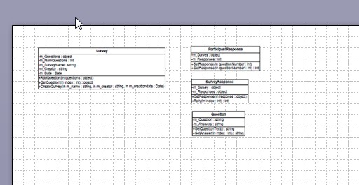
Question G: No, because all classes are self-explanatory
Question H: 3, No.
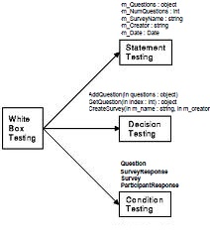
Question I: Differs because white-box testing tests the functionality of the software system.

Question H: Yes, both White-Box testing and Black-Box testing are necessary because one tests the internal workings of the system, whereas the other tests t he functionality.

